**Connecting the batteries.**

1. 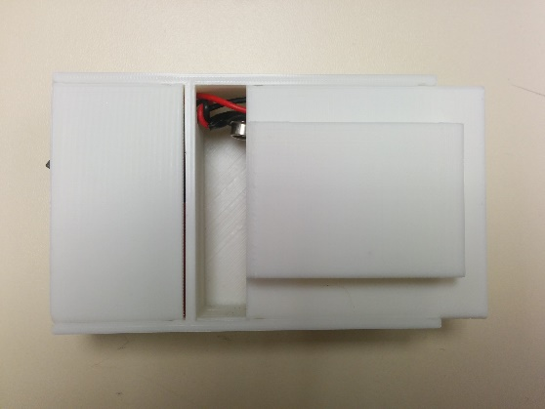Remove the battery cover by sliding it, pushing down on the top of the belt clip.
2. 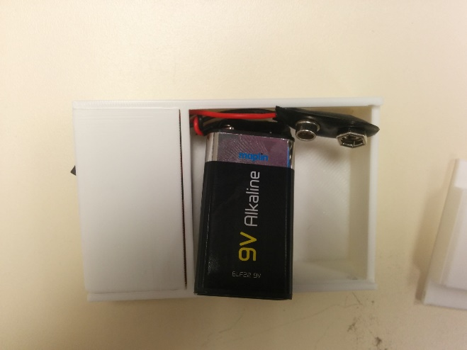Connect the two 9V batteries to the connectors.
3. 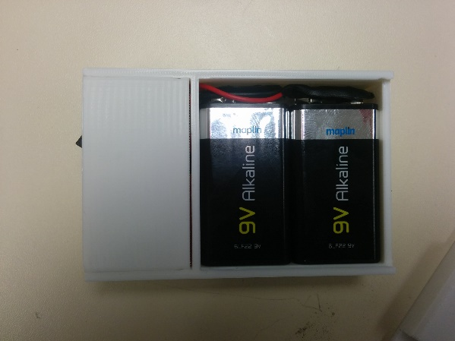Slide the batteries into place.
4. 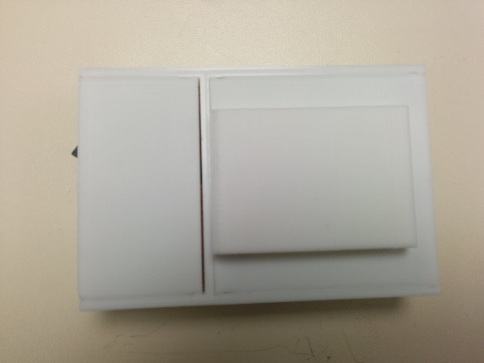Replace the battery cover.

**Please Note: Unfortunately, due to shipping restrictions, we are unable to ship Lithium Polymer batteries internationally.**

**Connecting the batteries.**

1. Remove the battery cover by sliding it, pushing down on the top of the belt clip.
2. Connect the two 9V batteries to the connectors.
3. Slide the batteries into place.
4. Replace the battery cover.

**Please Note: Unfortunately, due to shipping restrictions, we are unable to ship Lithium Polymer batteries internationally.**